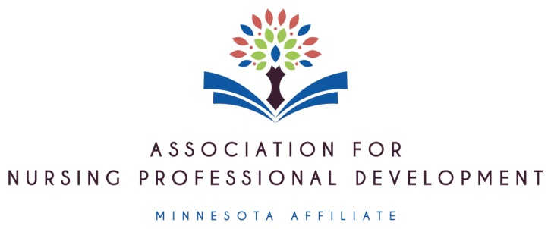
CALL FOR ABSTRACTS ANPD MN 2026 Fall Conference: Podium
Navigating Positive Change in Nursing Practice

Disseminate your expertise and grow in your profession. Consider being a presenter!

Podium presentations: Seeking 15 minute presentations related to Nursing Professional Development. Priority will be given to the topics listed below although other topics are welcome.
- Technology in nursing education
  - AI integration in nursing education
  - Simulation
  - Other creative teaching strategies that utilize technology
- Change management: How to support preceptors with changes. Best ways to implement change.
- Teaching strategies—esp. those that promote active learning and are inexpensive
Abstract Submission
Focus of this conference will be advancing the practice of nursing professional development through networking, learning, and reflection. Content should be relevant to the practice of Nursing Professional Development.

If your submission is selected, you agree to be present at the conference on Friday, October 30, 2026.

We welcome you to apply for more than one presentation but please list each on a separate form.

Name & Credentials/job title | Email for communication (personal email addresses tend to work better with group messaging)
*Please identify the primary presenter for this conference with an asterisk

- Title of your presentation:
- Brief abstract description:

If you think you will need more than 15 minutes, please let us know how long you would like for your presentation time: ____

Submission deadline is Friday, August 8, 2026.
Send submissions to: Minnesota-ANPD@outlook.com and Lchecky@hotmail.com
Accepted submissions will be notified in the month of September.

Not a member? Consider joining ANPD MN affiliate to grow in your nursing professional development practice. Discover great resources and networking platforms with our affiliate. Check us out: https://www.anpd-mn.com/

